Farringdon Neighbourhood Development Plan
Strategic Environmental Assessment and Habitat Regulations Assessment
--------------
Screening Report
Prepared by Officers of East Devon District Council

May 2020
1.0 Introduction
  - The purpose of this report is to assess the draft proposals in the Farringdon Neighbourhood Development Plan (hereafter referred to as the FNP) to determine whether it requires a Strategic Environmental Assessment (SEA) in accordance with the European Directive 2001/42/EC and associated Environmental Assessment of Plans and Programmes Regulations 2004. An SEA is required under this legislation for all plans which may have a significant effect on the environment.
  - This report will also screen to determine whether or not the FNP requires a Habitats Regulations Assessment (HRA) in accordance with Article 6(3) of the EU Habitats Directive and with Regulation 61 of the Conservation of Habitats and Species Regulations 2010. An HRA is required when it is deemed that the implementation of the plan is likely to cause negative significant effects on protected European Sites (Natura 2000 sites).
  - The conclusion of the assessment is that the FNP is unlikely to have a significant effect on the environment so an SEA in not required to accompany the Plan. It is also unlikely to have a negative impact on any Natura 2000 sites so should not be subject to HRA.
  - This report was sent to the three statutory consultees designated in the Regulations (Historic England, Environment Agency and Natural England) to elicit their views on the findings with a 5 week response period. All three consultees agreed with the District council’s conclusion.

2.0 SEA screening
  - The basis for Strategic Environmental Assessments and Sustainability Appraisal legislation is European Directive 2001/42/EC and was transposed into English law by the Environmental Assessment of Plans and Programmes Regulations 2004, or SEA Regulations. Detailed Guidance of these regulations can be found in the Government publication ‘A Practical Guide to the Strategic Environmental Assessment Directive’ (ODPM 2005).
  - The objective of SEA is 'to provide for a high level of protection of the environment and contribute to the integration of environmental considerations into the preparation and adoption of development plans.... with a view to promoting sustainable development’ EU Directive 2001/42/EC (Article 1).
  - Although there is no definitive guidance stating that a Neighbourhood Plan will require an SEA, Local Authorities are legally obliged to advise the plan producers as to whether an SEA is required.
  - To ascertain if SEA is required, a “screening” exercise has been undertaken by East Devon District Council evaluating the proposals the FNP against the criteria set out in the SEA Directive. This criterion is set out in the SEA Directive and can be found in Figure 1.
  - Should the screening report reach the conclusion that that plan will have a significant impact on the environment; a full SEA should be undertaken.
  - If the conclusion is that a full SEA is not required, any significant variations or additions to the Neighbourhood Plan will also be subject to screening.
  - An SEA has been undertaken as part of the adopted East Devon Local Plan 2013-2031 and has been taken into account whilst undertaking this screening assessment.

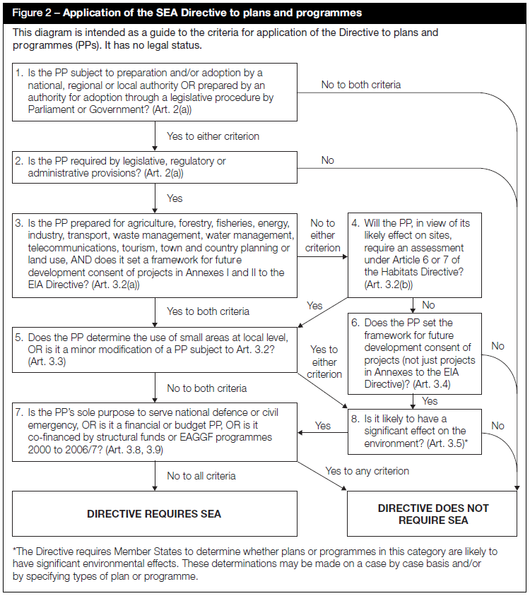
Figure 1: Application of the SEA Directive to plans and programmes
3.0 Farringdon Neighbourhood Plan

  - The Neighbourhood Plan has been in production for approximately four years. It has undergone significant consultation and they are currently at a stage of finalising draft proposals.
  - East Devon District Council has been kept abreast of progress and has offered support and guidance to the Neighbourhood Plan group and therefore can be confident in the Plan’s direction of travel.
  - Farringdon does not have a Built-up Area Boundary in the recently adopted Local Plan and is generally not considered suitable for open market housing, unless otherwise promoted through a Neighbourhood Plan.
  - The key point of the Neighbourhood Plan is the group’s ambition to allow a small amount of development within the Parish to meet an identified need for self-build homes for older people wishing to downsize and remain in the Parish. These proposals, limited to a maximum 12, single-storey, size-restricted, houses within existing gardens are not considered likely to result in a significant environmental effect. As no specific sites are allocated, there is potential for applications to develop in the curtilage of, or in close proximity to, the 17 listed structures in Farringdon (including 2 Grade 11* listed), but Policy Farr5 is worded to ensure that the setting of heritage assets is taken into account. Whilst the plan will also include various other policies, they are fairly general in nature and are considered very unlikely to have a significant environmental effect. Should this circumstance change it will be important to rescreen the plan to take any changes into account.
  - On this basis, this screening report has considered the potential for significant environmental effects from the proposed new housing.
  - A draft of the Neighbourhood Plan is attached to the consultation and available on the website.

Figure 2: Screening assessment against the criteria for whether the FNP requires an SEA.
Stage | Y/N | Reason
Is the FNP subject to preparation and/or adoption by a national, regional or local authority OR prepared by an authority for adoption through a legislative procedure by Parliament or Government? (Art. 2(a)) | Y | The Plan will be prepared by the Parish and adopted by East Devon District Council as part of the Development Framework, subject to a successful referendum.
Is the FNP required by legislative, regulatory or administrative provisions? (Art. 2(a)) | Y | The Plan meets the characteristics set out in the Government’s Practical Guide to the SEA Directive in that that it will be publicly available, prepared in a formal way and probably involving consultation with interested parties.
Is the FNP prepared for agriculture, forestry, fisheries, energy, industry, transport, waste management, water management, telecommunications, tourism, town and country planning or land use, AND does it set a framework for future development consent of projects in Annexes I and II to the EIA Directive? (Art 3.2(a)) | Y | The NP is prepared for Town and Country Planning and land use and may provide the framework for development of a scale that would fall within Annex II of the EIA Directive at a Neighbourhood Area level.
Does the FNP determine the use of small areas at local level, OR is it a minor modification of a PP subject to Art. 3.2? (Art. 3.3) | Y | The NDP will determine the use of small areas at a local level.
Is it likely to have a significant effect on the environment? (Art. 3.5) | N | See screening assessment for environmental effects in figure 3 of this report.

Directive Does Not Require SEA
4.0 Screening Assessment for Environmental effects

  - Under step 8 of the Application of the SEA directive (Figure 1), in order to establish whether a plan requires an SEA, it was necessary to conduct a thorough assessment of whether the plan was likely to have a significant effect on the environment.
  - The table below sets out the criteria by which the site allocation in the plan should be judged, as outlined in Article 3.5 of the SEA Directive.

Figure 3: Environmental impact screening assesment
Criteria for determining the likely significance of effects (Schedule 1 of SEA regulations) | Is the ANP likely to have a significant environmental effect? | Justification for Screening Assessment
The degree to which the plan or programme sets a framework for projects and other activities, either with regard to the location, nature, size and operating conditions or by allocating resources. | N | The thrust of the FNP is to restrict any further development to a maximum twelve small-scale, individual self-build houses in response to the findings of the recent housing needs assessment. In the Local Plan, Farringdon is generally not considered to be a suitable place for further open market housing development, due to a lack of services and facilities meaning residents generally use the private motor vehicle to access facilities such as schools and shops. There is a significant employment site within the parish and the knock-on effect of providing older people’s housing is that family homes will be ‘freed up’ enabling employees to live close to their place of work. Farringdon is in close proximity to the new town of Cranbrok and it is possible that future, strategic development will fall within the Parish, however this is outside the scope of the neighbourhood plan.
The degree to which the plan or programme influences other plans and programmes including those in a hierarchy. | N | The FNP must be in general conformity with the adopted East Devon Local Plan and have regard to national policies. It must also be compatible with EU law and the ECHR obligations. It is not considered to have a particular influence on any plans other than the planning applications that will dictate the implementation of FARR5.
The relevance of the plan or programme for the integration of environmental considerations in particular with a view to promoting sustainable development. | N | The neighbourhood plan will need to contribute towards the achievement of sustainable development, as required by the “basic conditions” on which the plan will be judged by at examination. New self-build housing will enable existing residents to downsize into accessible housing better suited for their needs, it will also release family housing onto the market. Whilst Farringdon lacks facilities, it does have a large amount of employment available and is close to bus stops and the wide range of facilities at Cranbrook.
Environmental problems relevant to the plan or programme. | N | Farringdon does not have any significant environmental problems that the Neighbourhood Plan is likely to impact.
The relevance of the plan or programme for the implementation of Community legislation on the environment (e.g. plans and programmes linked to waste management or water protection). | N | These community legislation types are not relevant to the FNP and will not need to be considered.
The probability, duration, frequency and reversibility of the effects. | N | As the Neighbourhood Plan will not be allocating a site, this will not apply.
The cumulative nature of the effects. | N | By limiting the new housing to 12 (one per year) the cumulative effects of the FNP are not considered to have a significant effect on the environment.
The trans-boundary nature of the effects. | N | The FNP only sets a framework for development within the Neighbourhood Area which corresponds to the existing parish boundary. The scale of development it will impact upon is unlikely to have a significant effect on neighbouring areas. Future strategic development/expansion of Cranbrook may impact upon the Neighbourhood Area but this is beyond the scope of the Plan.
The risks to human health or the environment (e.g. due to accidents). | N | There are no risks to human health identified, other than the usual risks associated with the construction of dwellings and a small increase in traffic running along narrow, country lanes.
The magnitude and spatial extent of the effects (geographical area and size of the population likely to be affected). | N | The FNP is concerned only with development within the Parish of Farringdon. If there are any effects they are not considered to be wide ranging.
The value and vulnerability of the area likely to be affected due to: special natural characteristics or cultural heritage; exceeded environmental quality standards or limit values; intensive land-use. The effects on areas or landscapes which have a recognised national, Community or international protection status. | N | No sites are proposed for allocation and the thrust of the Plan is protective in nature.
  - Conclusion

  - The Farringdon Neighbourhood Plan does not require a Strategic Environmental Assessment. The Neighbourhood Plan will provide for a very small level of development over and above the provision in the Local Plan (around 12 individual houses over 12 years), and will not otherwise impact upon internationally or nationally important features which would be deemed to have a significant environmental effect.
  - The Local Plan considered that exceptions sites of around 15 houses would be acceptable in rural parishes and the Neighbourhood Plan does not promote development over and above this level. The housing proposed under FARR5 is not affordable ‘exceptions’ housing, however it does meet a specific identified local need. The impact of individual dwellings within curtilages will be assessed through the planning application process and those applications which would result in a specific harm eg to a listed building, will not be permitted.

5.0 Habitat Regulations Screening Assessment

  - The draft policies of the plan (attached) have been used to undertake this initial screening assessment. As the conclusion is that a full Habitat regulations screening is not required, any variations or additions to the aims and objectives will be subject to a further screening. A draft screening report was produced as part of the production of the emerging Local Plan and has been taken into account in undertaking this screening assessment.
  - The Conservation (Natural Habitats &c.) Regulations 1994 (The Habitats Regulations) transpose the requirements of the European Habitats Directive 92/43/EEC into UK law. The Habitats Directive and Regulations afford protection to plants, animals and habitats that are rare and vulnerable in a European context.

  - Habitats Regulations Assessment (HRA) is a systematic process through which the performance of a plan or project can be assessed for its likely impact on the integrity of a European Site. European Sites, also referred to as Natura 2000 sites, consist of Special Protection Areas (SPA), Special Areas of Conservation (SAC);Potential Special Protection Areas and candidate Special Areas of Conservation (pSPA and cSAC); and listed or proposed Ramsar sites.

  - Article 6(3) of the Habitats Directive states:
‘Any plan or project not directly connected with or necessary to the management of the site but likely to have a significant effect thereon, either individually or in combination with other plans and projects, shall be subject to appropriate assessment of its implications for the site in view of the site’s conservation objectives’.
  - Sites which are potentially relevant to the Farringdon Neighbourhood Plan are the Pebblebed Heaths as, although they lie a number of kilometres away from Farringdon, development may be required to contribute to mitigation measures. There is a County Wildlife Site in an abandoned swimming pool at (former) Farringdon School and several ancient orchards, however none of these sites should be affected by development, particularly housing (as FARR5 allows it only in existing curtilages),

  - Natural England will be consulted on this document by the District Council.

Screening Criteria Questions
- Is the Neighbourhood Plan directly connected with, or necessary to the management of a European site for nature conservation?
No
- Does the Neighbourhood Plan propose new development or allocate sites for development?
No. The Plan allows for up to 12 single dwellings to be constructed within existing curtilages but no specific sites are identified. Any development is likely to be extremely limited in size and scale.
The objectives in the Neighbourhood Plan accord with the Local Plan for the District which is subject to an HRA. A screening opinion was provided by Land Use Consultants early in the Plan production process and an HRA was completed by Footprint Ecology before, and informed, the adopted Local Plan. It indicated that the Local Plan will have sufficient policy provisions to enable the subsequent delivery of necessary measures to avoid and mitigate adverse effects on the integrity of European Sites.
- Are there any other projects or plans that together with the Neighbourhood Plan could impact on the integrity of a European Site?
No
  - Conclusion

  - The Farringdon Neighbourhood Plan does not require a Habitat Regulation Assessment.

  - The Farringdon Neighbourhood Plan is unlikely to have an adverse effect on a European site (as defined in the Conservation of Habitats and Species Regulations 2010 (d), alone or in combination with other plans and projects. It does not propose a level of development significantly over and above that in the adopted Local Plan (which was itself subject to HRA).

